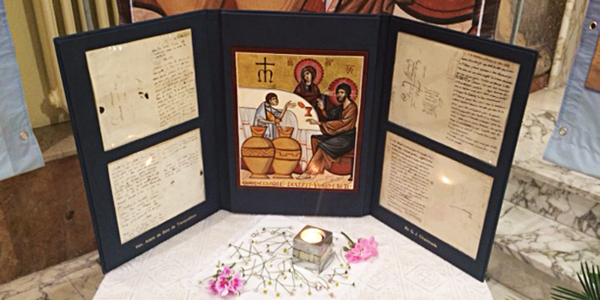
IntroducTIon to
PRAYER SERVICE WITH BICENTENNIAL ICON TRIPTYCH

As a special celebration of our charism during the bicentennial, a uniquely Marianist icon will be traveling the Marianist world. The icon triptych includes a depiction of the wedding feast at Cana created by an Italian Marianist, Bro. Salvatore Santacroce. Flanking the art are original letters penned by Venerable Adèle de Batz de Trenquelléon and Blessed William Joseph Chaminade. The icon’s pilgrimage began on May 15, 2016, in Agen, France, the birthplace of the Marianist Sisters. It will complete its journey in Singhpur, India, on Chaminade Day — January 22, 2018. Along the way, it will be a focal point for events in countries as varied as Austria, Togo, Korea and Mexico. The icon will be in the Province of the United States and associated locations from November 2016 through January 2017. (https://www.marianist.com/icon200)

As an aid to the Marianist communities in the Province of the United States which the icon triptych will visit, the following OUTLINE FOR PRAYER SERVICE WITH BICENTENNIAL ICON TRIPTYCH is offered as a resource. While it can be used “as is,” it is not meant to be prescriptive. Rather, it is designed to be adaptable to the specific resources and needs of each community and each celebration.
Certain themes and understandings guided the preparation of this service and may be helpful in considering how to adapt it. Always in the background is the Bicentennial theme, To know, love and serve, as outlined in the Joint Circular “Celebrating the Bicentennial of Our Foundations,”
These words encompass the dynamic of Marianist spiritual life: To know, love and serve Christ. To know, love and serve Mary. To know, love and serve the Marianist charism. … We propose that the celebration center its attention, in a particular way, on the meaning and mission which our founders wished to give our religious life within the life and mission of the Family. … The celebration of two hundred years of history requires us to look at the past with gratitude, … This calls us, therefore, to scrutinize the past in order “to know” our own charism better, in order to “love it” and “serve it” in the present which, following the exhortation of the Pope, requires us to live with passion, a “passion” that not only is fed by living the charism, but which springs, above all, from the passion for Christ and his Kingdom. … In this way, therefore, we hope that the celebration of the Bicentennial might be an occasion to renew our “passion” for the Marianist religious vocation, a passion that will lead us to live this vocation with greater joy and commitment, and at the same time, be a call and means by which others might feel challenged and decide to follow it.
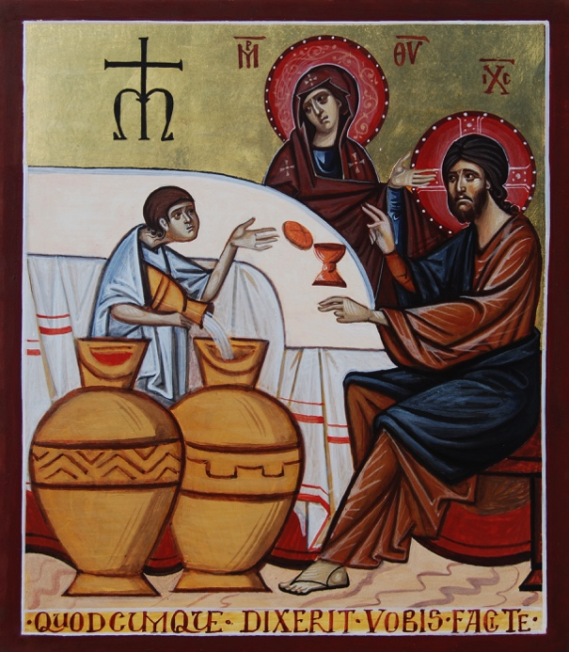
In the foreground – literally – is the Bicentennial Triptych. The icon triptych is a powerful focus of reflection on the themes just described, bringing together an iconic representation of a Gospel reading central to Marianist spirituality with tangible mementos of our Founders. The prayer service seeks, through word and gesture, through visual art and music, to lead us deeper into the Bicentennial celebration.
Two important guidelines should be kept in view. First, in the Eastern Christian tradition, icons are a powerful vehicle for prayer, bringing the faithful into contact with the holy ones visualized in the icon with an immediacy unfamiliar to most Western Christians. This prayer service is in no way a tutorial on the meaning and veneration of icons, but it does include several gestures of reverence toward our Mother Mary and our Founders, expressing our gratitude and reinforcing our spiritual alliance. Any changes made to the prayer service should show an awareness of and respect for the customs of our Eastern brothers and sisters.
Second, we must always be circumspect in the language we use in veneration of Mary and the saints and in our petitions for their intercession. The familiar Marianist Doxology is a good rule of thumb: “May the Father, the Son, and the Holy Spirit, Be glorified in all places through the Immaculate Virgin Mary!” And, we might add, through Venerable Adele and Blessed Chaminade.

OUTLINE FOR PRAYER SERVICE WITH BICENTENNIAL ICON TRIPTYCH
Environment:
A table or other surface should be prepared in advance for the triptych. It should be positioned, and elevated if need be, so that all can see it during the service. It would be appropriate to dress the table with fabric, flowers, and candles. A brazier or thurible for incense should be prepared and placed before the icon; some incense may be added just before the service.

If portraits of Chaminade and Adele are available, these might be fitting companions for the triptych.

Ministers:
Prayer Leader
One or more readers
One or more song leaders/musicians

ORDER OF SERVICE

The Presider stands and invites all to stand as they are able.
HYMN
recommended: Let Your Will Be Done Through Our Lives, esp. verses 1 and 4 (Tony Alonso)
other options: Mary, First Among Believers; Litany of Mary; Among All; Sing of Mary; There Is Nothing Told; Jesus, Come! For We Invite You; Come As We Journey Along Our Way/Santa María del Camino; Stainless the Maiden; Blessed One; Hymn to Mary Immaculate; She Will Show Us the Promised One

INTRODUCTION AND OPENING PRAYER
Presider:
We gather as members of the worldwide Marianist Family to give thanks to God for the many blessings bestowed in our own lives and upon the whole Marianist family over the last 200 years. The bicentennial theme “To know, love and serve,” prompts us to immerse ourselves in the sources of our charism, so that we may reflect upon and embrace it, and embody it in all that we do. In this way, under the guidance of the Holy Spirit and protection of Mary, we look forward to a future of promise even in the midst of sometimes unsettling change.
We come together [today, this evening] to celebrate the visit of the Bicentennial Icon, a beautifully artistic expression of the Wedding at Cana. Through the power of Jesus and at the prompting of Mary, there was no shortage of drink for all, and the wine only got better as the celebration went on. It’s no wonder that this gospel reading has been one of our core points of reference as Marianists, an inexhaustible wellspring of reflection and inspiration.
Along with the Bicentennial Icon, we are privileged to be able to see up close two letters from our Founders, Blessed Chaminade and Venerable Adele. Handwriting is intimate and revealing, has a way of making its author present to us. These letters remind us that our Founders and the early Marianists faced challenges not so different from those we ourselves encounter.
And so, as we gather in the name of the one who changed water into wine, and in imitation of his Mother, let us open our hearts and minds to know our past and contemplate our future as we pray:
O God of abundant mercy and love,
you always provide us with more than we ever imagined.
Responding to the need brought to his attention by Mary,
your Son Jesus turned water into wine
at the wedding feast at Cana.
Those overflowing jars are a symbol of your prodigal love for us.
As we reflect on our Founders
and two centuries of Marianist life and activity,
open our hearts ever more to the life you offer.
Imperfect jars though we may be,
make us unafraid to come before your Son
with our fears and limitations.
Open our eyes to the needs of the world around us,
and prompt our hearts to cooperate with you.
Take the good will and generosity that we display
and multiply it a hundred fold for others.
We ask this in the name of your Son,
who turned water into wine,
Jesus Christ, the worker of miracles.
He is Lord forever and ever.
All:
Amen.
(adapted from Jerry Galipeau, Gathered to Serve, Prayers for Parish Leaders, p. 86, and reflections from the 2015 Province Assembly)
The Presider invites all to sit for the psalm.

PSALM
recommended: Psalm 104 with Howard Hughes tone
other options: Psalms 29, 42, 98
A Reader (or Readers, if using the Choral Reading) comes forward to share the Gospel reading.

READING
John 2:1–11 (The Wedding at Cana)
(Optional Choral Reading)

(OPTIONAL BRIEF REFLECTION/HOMILY)
Could be given by one person or several. If there is to be no homily or reflection, allow a suitable interval for silent reflection.

REFLECTING ON THE TRIPTYCH
Presider:
I invite you now to let the triptych, and especially the icon, be a focus of meditation as we hear phrases from Scripture, the writings of our Founders, and other reflections.
The reflections can be read by one or several readers.
Sung or spoken response:
Taste and see the grace eternal; taste and see that God is good. (“All Who Hunger,” Bob Moore)
(other suitable responses or refrains might be chosen)

Reader:
Our Marianist brother Salvatore Santacroce, SM, from the Region of Italy, is the artist who wrote this icon. He reflects,
The icon of the “Wedding at Cana” brings into focus several key figures: Christ, the Mother of God, the servants, the amphorae (jars) and the table prepared for the feast.
Mary’s eyes express gentleness, and affectionate concern, as she appeals with outstretched hand, saying the words “Do whatever he tells you.”
Urged by his Mother into the reality that awaits him, Christ looks beyond the immediate, seeing his “hour” in the water that turns red and with cup and bread on the table, which anticipate and foreshadow his sacrifice.
The servant fixes his astonished gaze on Christ and comes to a new enlightenment that, through faithful obedience, is able to welcome the eruption of Divine Power within human reality.
At the top, the Marianist Cross strongly reaffirms our alliance with Mary to bring to the many tables of humanity “the good wine” the wine that has been “kept until now.”

Response:
Taste and see the grace eternal; taste and see that God is good.

Reader:
Sr. M. Franca Zonta, the Superior General of the Daughters of Mary Immaculate, offered these thoughts inspired by Venerable Adele’s letter enclosed in this triptych:
As someone has rightly said, it is not so much the why we entered religious life that counts, no matter how banal, superficial or profound these reasons may be. Rather, what matters is why we remain, why we persevere. …
May this Jubilee Year be an occasion for the purification of our “yes,” eliminating what time may have tarnished. “Let us continue to prepare our hearts,” as Adele says, so that our love may complement the boundless love that spurred Adele and Chaminade to generate the Family of Mary, so that her Son might be known, loved and served!

Response:
Taste and see the grace eternal; taste and see that God is good.

Reader:
Let us take to heart other words by Venerable Adele:
“May everything be renewed in us: our heart, our language, and our works.”
“We are but one family; let us have but one heart and one soul, and belong to God alone.”
“We have a great deal of work to do; yet, let us never give way to discouragement. What can we not obtain from a God who is born in a crib for love of us? If we place our hope in him alone, we shall not be disappointed.”

Response:
Taste and see the grace eternal; taste and see that God is good.

Reader:
Marianist Superior General Manuel J. Cortés gives us these reflections on Blessed Chaminade’s letter housed in the triptych:
We can never forget that Marianists are servants, not masters or lords; we are servants, children of the Servant of the Lord. In confronting problems and difficulties, we will have a share in the invincibility promised to Mary, from the beginning, if we maintain, above all, fraternal communion animated “by the direction of the Spirit of Jesus Christ, under the auspices of Mary.”
A spirit of service, following Mary, the Servant of the Lord, … and fraternal communion in the purest, evangelical way, … these are two principle motors, without which our lives and our mission would lose its consistency and meaning. What a good message upon which to meditate and “keep in our hearts” during the celebration of our Bicentennial!

Response:
Taste and see the grace eternal; taste and see that God is good.

Reader:
Let us take to heart other words by Blessed Chaminade:
“We have taken for our motto, the great phrase so full of sense and truth which Mary said to the servants at the wedding of Cana: ‘Do all that he will tell you.’”
“It seems to me that we must not become discouraged if we encounter some obstacle in the way of necessary change. Never has change been done and never will it be done without difficulty. With patience we will come to the end of all.”
“Ours is a work, a magnificent work. If it is universal, it is because we are missionaries of Mary, who has said to us, ‘Do whatever he tells you.’ Each one of us has received from the Blessed Virgin a commission to work at the salvation of our brothers and sisters in the world.”

Response:
Taste and see the grace eternal; taste and see that God is good.

VENERATING THE ICON
Presider:
Please stand.
The veneration of icons is deeply rooted in the Christian tradition, especially among our Eastern brothers and sisters. Some of us here may also have an affinity for these holy images that serve to connect us with Our Lord, our Lady, and the saints, while for others we may simply be moved by their beauty or feel a connection to mystery in their presence.
At this time we share a simple gesture of reverence for this Bicentennial Icon. In doing this, we offer praise and thanksgiving to our Lord and Savior, glorifying him through his Mother Mary and the witness of our Founders Blessed Chaminade and Venerable Adele.
As the icon is reverenced with incense, I invite you to make the sign of the cross.
The Presider or other participant adds incense to the thurible or brazier. Then he or she incenses the icon in the customary way. As this is done, members of the assembly sign themselves with the Sign of the Cross. Then, the Presider or musician leads the Marianist Doxology.
Marianist Doxology (preferably sung):
May the Father, the Son, and the Holy Spirit,
Be glorified in all places through the Immaculate Virgin Mary!

Presider:
I invite you to come forward now to show a sign of reverence to the icon. In doing so we acknowledge the person of Mary and who she is to us and to our founders.
As you approach the icon, you might make the Sign of the Cross. Gaze upon the icon, then conclude with a reverent touching of icon, or a full bow from the waist. Please refrain from kissing the icon.
The Presider and perhaps a few other coached participants can begin the procession of veneration. Depending on the space available and arrangement of chairs, more than one person can reverence the icon simultaneously.
During the procession, a setting of the Magnificat and/or other appropriate Marian songs or chants may be sung. A recommended setting is “My Soul Rejoices in God,” (Collegeville Composers Group/Psallite). Other options are settings by Owen Alstott, Bernadette Farrell, David Haas, Howard Hughes, and Michael Joncas. Other possible songs or chants include “Holy Virgin Mary,” Lucien Deiss, Ave Regina Caelorum (Queen of the Heavens, We Greet Thee).

INTERCESSIONS
When all have returned to their places, the Presider stands and invites all to stand.
Presider:
Please rise.
Mindful of our rich Marianist heritage and God’s many blessings upon us, let us offer prayers of thanksgiving and petition to the Lord, asking the intercession of our Blessed Mother.
Reader:
We thank you, loving God, for the Marianist Charism imparted to us by Blessed Chaminade, Venerable Adele and all of our Marianist ancestors. Their faithful response to the promptings of the Spirit laid the foundations of all our works today. May we continue their good work with confident fidelity.
All:
Mary, full of grace, intercede for us.
(another spoken or sung response could also be used)
Reader:
We thank you, loving God, for the bicentennial jubilees of the Daughters of Mary Immaculate and the Society of Mary. May these jubilees deepen the faith of the Marianist religious, increase their zeal, and draw others to embrace the missionary charism of Blessed Chaminade and Venerable Adele.
All:
Mary, full of grace, intercede for us.
Reader:
We thank you, loving God, for the embodiment of the Marianist spirit in the branches of our common family. As men and women religious and lay Marianists, may we continue to meditate on Mary’s Mission, join hands in work and prayer, and collaborate in the growth of the Marianist Family.
All:
Mary, full of grace, intercede for us.
Reader:
We thank you, loving God, for the many missionaries whose efforts have implanted Marianist life and spirit in Mexico, India, Peru, Korea and Eastern Africa. May their efforts, in cooperation with local vocations, and supported materially and spiritually by the whole Province, continue to give witness to hope and selflessness in carrying out Mary’s command, “Do whatever He tells you.”
All:
Mary, full of grace, intercede for us.
Reader:
We thank you, loving God, for the donors and benefactors who support us and partner with us in our mission. Bless them for their generosity, and enable us to be wise stewards of our resources.
All:
Mary, full of grace, intercede for us.
Reader:
Let us pray for members of the Marianist family who are facing illness and suffering. [An opportunity might be given for people to offer names out loud.] May they know God’s healing touch and be brought to wholeness of body, mind and spirit.
All:
Mary, full of grace, intercede for us.
Reader:
Let us recall the members of the Marianist family who have gone before us and who have been mentors and inspirations to us. [An opportunity might be given for people to offer names out loud.] May God have mercy on them and may they share in the fullness of Christ’s joy in the company of Mary and all the saints.
All:
Mary, full of grace, intercede for us.
Reader:
Loving God, as consecrated religious in the Marianist family, may the members of the Society of Mary and the Daughters of Mary Immaculate heed Pope Francis’ call to live their Marianist religious life radically and with joy. May the fruit of these bicentennials enrich the entire Marianist family. Through our witness and prayer, inspire faith-filled and zealous religious vocations for these congregations, “witnesses who will never die.”
All:
Mary, full of grace, intercede for us.

LORD’S PRAYER
Presider:
In company with the Blessed Virgin Mary,
and all our ancestors in faith,
let us pray as the Lord Jesus taught us:
Our Father . . .

CLOSING PRAYER
Presider:
Let us pray.
O Lord, gathered together in your name, we give thanks for these two hundred years of Marianist religious life of which we are heirs and joyful witnesses. You, who inspired in Blessed William Joseph Chaminade, together with Venerable Adele de Trenquelléon, the foundation of our institutes, grant us the grace to live the spirit which animated their lives, the strength of their faith and their apostolic courage. Help us, who follow their footsteps, to know, love and serve passionately, in alliance with Mary, the mission confided to her in the history of salvation, that of forming in faith a multitude of brothers and sisters of your Son.
All:
Virgin Mary, Mother of Jesus, our Mother, we entrust to your maternal care the fruits of this Jubilee Year. Help us renew our life and our mission. Awaken in us a passion for the Kingdom of God, for which your son gave his life. Fill us with your merciful love, attentive to all the needs of the men and women with whom we share this time in history. Like you, we sense our poverty and weakness, but we trust in the power of the Spirit to strengthen us. Make our communities a home for love, for justice and for peace. So, in your name, we will continue bearing witness to the presence of Christ and we will show, as our founders desired, that even today the Gospel can be lived with the full rigor of its letter and its spirit.
All:
Amen.

BLESSING AND DISMISSAL
Option 1:

Presider:
For all that God can do within us,
for all that God can do without us,
All:
Thanks be to God.
Presider:
For all in whom Christ lived before us,
for all in whom Christ lives beside us,
All:
Thanks be to God.
Presider:
For all the Spirit wants to bring us,
for where the Spirit wants to send us,
All:
Thanks be to God.
Presider:
Listen, Christ has promised to be with us in the world as in our worship.
All:
Amen. We go to serve him.
Thanks be to God.

Option 2:

Presider:
May Our Lord Jesus Christ and Mary Our Mother
encourage us and strengthen us
to do and say what is good: now and for ever.
All:
Amen.

Option 3 (if the prayer leader is a priest):

Priest:
The Lord be with you.
All:
And with your spirit.
Priest:
May Almighty God bless you,
the Father, the Son, and the Holy Spirit.
All:
Amen.
Priest:
Go in peace.
All:
Thanks be to God.

CLOSING HYMN
recommended: Salve Regina
other options: How Strong the Faith and Mission; Come As We Journey Along Our Way/Santa María del Camino

