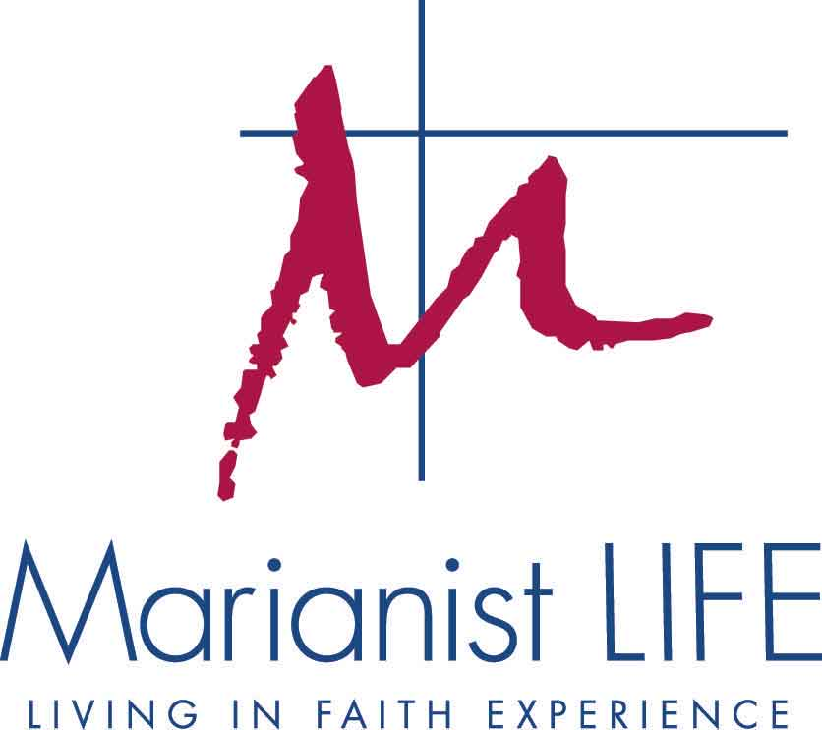

January 15, 2016

Dear Administrators, Institutional Contacts, and Moderators,

Greetings from the Marianist LIFE Pacific Coordinating Team! My name is Soane Uiagalelei, and joining me on this year’s Coordinating Team are Joey Klobas (CA), Maimoa Fineisoloi (HI), Suzeth Carreon (HI), Jen Bauer (HI), Ismael Ruiz (CA) and Makena Hamilton (TX).

Marianist LIFE Summer Program will be held at CYO Camp and Retreat Center, Occidental, CA, from June 19 through June 24 for students. In addition, school and parish moderators will meet for mandatory preparation and orientation starting on June 16, 2016 until the students arrive. Moderator and Program Days are mandatory for ALL new and returning moderators. It is important that we build Christian community and learn about the summer program prior to the students’ arrival.

Attached is a packet of materials, including deadlines, which help to facilitate your selection and preparation process. We realize that your school or parish boasts a busy schedule, however, as participants in this national program, we humbly ask that you please abide by these deadlines. It will help facilitate our planning process.

The cost for Marianist LIFE participants will be $525 per student and $675 per moderator. Booking and costs for air transportation to and from San Francisco International (SFO) remain the financial responsibility of the participating school/parish. Airport transportation is available for moderators and students to and from SFO only.

We have two activities during the Marianist LIFE Summer Program that call for advance preparation:

- Each school/parish is asked to prepare a morning, evening or night prayer service, as well as mealtime prayers for a specific day. These prayers are the gifts that your group will give to the entire Marianist LIFE community. Further guidelines and specific date assignments will be sent to you by April by the Regional Coordinator. There are some changes to the guidelines, so please read them carefully upon receipt.
- Each school/parish group should meet at least five times before coming to the summer program. These sessions should include bonding activities, faith sharing, prayer, social time, and planning for the prayer service. Some guidelines and suggested activities for these meetings will also be distributed in the future.

If you play a musical instrument and are willing to play for liturgies and other social events, please bring it with you. [Note: CYO Camp and Retreat Center has a piano for our use during prayer services.]

IMPORTANT TRAVEL GUILDELINES FOR STUDENTS TRAVELING FROM HAWAI’I:
The National Office will not book student group travel. This allows for your students to use employee/family discounts or mileage to defray their costs.

Honolulu-San Francisco flights preferred in order to best coordinate ground transportation:
Saturday | United 1575 | Depart HNL 10:40pm | Arrive SFO 6:30am (Sunday)
Friday | United 1670 | Depart SFO 7pm | Arrive HNL 9:40pm

Kahului-San Francisco flights preferred in order to best coordinate ground transportation:
Saturday | United 1760 | Depart OGG 10:59pm | Arrive SFO 7:01am (Sunday)
Friday | United 1581 | Depart SFO 7pm | Arrive HNL 9:25pm
Travel Guidelines Continued
Students not traveling with their school/parish to San Francisco before LIFE must
- be at the designated SFO baggage claim no later than 6:30am on Sunday, June 19^{th,} allowing time for possible flight delays/cancelations for personal travel
- forward flight information to his/her moderator and the Regional Coordinator so the team can plan accordingly

Students not traveling with their school/parish from San Francisco International after LIFE must
- be picked up from SFO only
- not arrange for flights from SFO before 7pm on the last day of the program

CHILD PROTECTION TRAINING (rev. 2016)
In a continued effort to ensure our participants are safe, Marianist LIFE adult staff members must complete the Protect the Children/LawRoom training. We realize that some may have already received training through their schools and parishes. Protect the Children/LawRoom has been approved by the Marianist Province of the United States as the official course for Marianist LIFE. All moderators at Central, Pacific and South will complete this online course prior to the start of the summer program. This is an added effort to protect all participants in our care during the summer program.
- Those who have received Shield the Vulnerable training will be asked to add Marianist LIFE to their profile so the National Office can access course completion verification.
- For those without Shield the Vulnerable/Protect the Children training, information to register for the online course will be emailed to you in the February or March.
We thank you for your understanding and cooperation as we strive to keep Marianist LIFE effective and safe for all participants.

Let us know if we can serve you in any way. Please contact us for either of the following:

- Registration:
Toni Mesina & Sierra Christian marianistlife@sm-usa.org (215) 634-4116
- Summer Program & Travel Info:
Soane Uiagalelei soane808@gmail.com (808) 342-5545

Thank you for your continued cooperation and support of Marianist LIFE. Please continue to keep the team and participants in your prayers.

Peace,
Soane Uiagalelei
Regional Coordinator, Marianist LIFE Pacific
MODERATOR INFORMATION & PARTICULARS

Moderator Travel & Arrival Information

All adult moderators are to report to Moderator Days prior to the start of the summer student programs. More details regarding travel will be sent to you once you have completed and submitted your registration information to the national office; however, please note these initial details in the meantime:
- Airport transportation for Moderators and students will be available to and from the retreat center upon arrival and departure to and from San Francisco International Airport (SFO) ONLY
- If you are flying, please book your arrival time no later than
  - 10:30 AM on Thursday, June 16
- If you are driving or arranging your own ride to the retreat center, please arrive no later than:
  - 12 PM on Thursday, June 16
- Return flights should not be made before 7:00 PM on Friday, June 24.
- Accommodations are not available before June 16 and after June 24. Additional accommodations are at the expense of the individual moderator or institution.
- For further questions or information, please contact the Regional Coordinator or Head of Temporalities.

Moderator Day Attendance Policy

The purpose of Marianist LIFE moderator days is:
- To model the very essence and mission of Marianist LIFE by building small communities of faith prior to the students’ arrival
- To participate in faith formation experiences that help create healthy small faith communities for high school students to model throughout their LIFE week experience
- As a first-time moderator, to become familiar with Marianist LIFE and the various components, materials, and activities that take place throughout LIFE week
- As a returning moderator, to be notified of any program changes, to assist first-time moderators, and to build community with a new group of people

Because we strive to model and build healthy small faith communities, it is required that all new and returning moderators and Coordinating Team members are present for both Moderator Days and the student summer program in their entirety. All emergency situations must be discussed with the Regional Coordinator, in consultation with the National Coordinator.

Guest Policy

Due to the intense schedule and nature of Moderator Days and the summer program, Marianist LIFE does not allow Coordinating Team members’ and/or moderators’ friends or family members to attend, participate, or visit. Guests, friends, and family members are encouraged to attend Marianist LIFE during the Marianist Family Gathering during Moderator Days (see below).

Marianist Family Gatherings / Socials

Each regional summer program hosts a Marianist Family Gathering for friends, family members, and local lay and religious Marianists to gather in fellowship and prayer. Please encourage friends and loved ones to attend a Marianist Family Gathering this summer. RSVPs requested to National Office or Regional Coordinator.

Marianist LIFE Pacific CYO Camp & Retreat Center (Occidental, CA) - Saturday, June 18, 2016
Marianist LIFE Central Bergamo Center (Dayton, OH) - Saturday, July 16, 2016
Marianist LIFE South TECABOCA (Mountain Home, TX) - Sunday, July 10, 2016

Moderator & Staff Registration Form
Please complete this form on Word then print to sign it.

Last Name  Click here to enter text. | First Name  Click here to enter text. | School/Parish Name
Preferred name for badge  Click here to enter text. | Position/Title at School/Parish | School/Parish Address  Street  Click here to enter text.
City Click here to enter text.
State Click here to enter text.
Zip Click here to enter text.

*This contact information will be included in the contacts list distributed to students and adult moderators.
Personal Address  Street:  Click here to enter text.  City Click here to enter text.  State Click here to enter text.  Zip Click here to enter text. | Telephone  School/Parish (published in contacts list):  Click here to enter text.  Personal (not published in contacts list):  Click here to enter text. | Preferred Email Address  Click here to enter text.  Would you like the above email address included in the contacts lists students will receive? Yes No
*This information will NOT be included in the contacts list. |  | Birth Date  Day
Gender  Male Female | T-Shirt
Please check one LIFE staff position:
School/Parish Moderator | Auxiliary Moderator | Music Minister
Medical Staff | Chaplain | Audio/Visual
Marianist Young Adult Assistant | Coordinating Team | Night Chaperone/Lifeguard
What involvement have you had in youth/campus ministry and retreats?  Click here to enter text. | Please describe prior involvement with Marianist LIFE summer program or at your school/parish. Have you been involved this past academic year?  Click here to enter text. | Years of employment/volunteering at school/parish  Click here to enter text.  Religion  Click here to enter text.
*The Coordinating Team may need to contact you after June 1st regarding the summer program.
Please provide a phone number and email address at which you can be reached during the summer.
MEDICAL RELEASE AND HOLD HARMLESS

Date: Click here to enter text.

NAME of Adult Participant: Click here to enter text.

ADDRESS: Click here to enter text.

PHONE: Click here to enter text.

FUNCTION/ACTIVITY: Marianist LIFE Pacific

DATES AND TIMES OF ACTIVITY: June 16 – June 24, 2016 (adult participants)
June 19 – June 24, 2016 (student participants)

LOCATION OF ACTIVITY: CYO Camp & Retreat Center in Occidental, CA

RELINQUISH OF CLAIMS AGAINST the MARIANIST PROVINCE OF THE UNITED STATES

I recognize and acknowledge that there are risks in my presence and participation in the MARIANIST PROVINCE OF THE UNITED STATES sponsored program. I agree to indemnify, hold harmless, waive and relinquish all claims I may have against the MARIANIST PROVINCE OF THE UNITED STATES including any negligence claims on their part and its officers, agents, employees, representatives or volunteers arising out of, in connection with the transportation to and/or from the event, or any activity my child/ward participates in while attending the sponsored program.

MEDICAL RELEASE
My permission is hereby given to the representative of the MARIANIST PROVINCE OF THE UNITED STATES to authorize, by signature, whatever medical or surgical treatment may be considered necessary or advisable by the physician or nurse in attendance in the event of an accident or medical emergency involving:

Adult participant: Click here to enter text.

Adult Signature: Date: MM/DD/YY

(Attached a copy of participant’s current health benefit medical card)

Company Name and type of Plan: Click here to enter text.

Please check if the above is military insurance and dependent is not provided with a card. Provide information below:
Military Insurance Information: Click here to enter text.

Individual to contact in case of emergency Click here to enter text.
Relationship to Participant Click here to enter text.
Emergency Phone Number Click here to enter text.

Primary Care Physician Click here to enter text.
Phone Click here to enter text.
City Click here to enter text.
MEDICAL NOTIFICATION

Participant is a Student Adult Coordinating Team Member/Moderator/Staff Member

PARTICIPANT’S NAME Click here to enter text.

INSTITUTION

List any medications participant is bringing to the summer program
Student medications must be turned in to the medical staff upon arrival.
Medication Name | Dosage
Click here to enter text. | Click here to enter text.
Click here to enter text. | Click here to enter text.
Click here to enter text. | Click here to enter text.
Click here to enter text. | Click here to enter text.
Click here to enter text. | Click here to enter text.
Click here to enter text. | Click here to enter text.
Click here to enter text. | Click here to enter text.
(If additional space is needed, please attach an additional page)

List any medical issues of which our staff nurse should be aware (surgery, sleepwalking, illness …)

Click here to enter text.

Do you have any allergies or other reactions? (severe reactions to bug bites, fatigue, dehydration, allergies to food, aerosols, medications, etc.)

Click here to enter text.

I authorize the nurse to dispense.

Tylenol Ibuprofen Benadryl TUMS (Check all that apply)

These medications will be available. All others must be provided by participant.

Signature of Participant

ADULT PARTICIPANT AGREEMENT
AND CODE OF CONDUCT

Since 1970, the Marianists (Society of Mary) have offered a unique experience in building Christian communities of faith for groups of teenagers and moderators. As a faith formation and leadership training program, Marianist LIFE fosters an environment in which participants learn to build Christian community, reflect upon their experiences, and prepare consciously and responsibly to extend the richness of the Marianist LIFE tradition of their parish, school, and home communities.

These are standards and expectations that will aid in fostering the community spirit that Marianist LIFE has come to enjoy over the years:

- I agree to cooperate with the Marianist LIFE Coordinating Team, Moderators, Staff and Participants in order that we all might benefit and be enriched by this program.
- I will respect other people and myself regarding safety, courtesy and property.
- I agree to be present at all program sessions (not including Moderator socials) in their entirety, which include those that may extend late into the night.
- I agree to maintain a retreat atmosphere and remove myself from everyday luxuries, including regular use of cell/smart phones, laptops, tablets and/or other two-way communications devices and posting on social networking sites including Facebook, Twitter and Instagram while at the summer program.

I am aware that violations of this respect include, but are not limited to:
- The possession and/or use of illegal drugs
- The possession and/or use of alcohol outside of designated Moderator socials
- The use of tobacco during sessions and especially in the presence of minors
- Leaving the program site without approval of the Regional Coordinator as adults are needed for constant supervision of the minors in our care
- Possession and/or use of fireworks and firearms
- Vandalism or disrespecting property of any kind
- Disregarding the Vulnerable Persons document
- Any other significant violation of rules of safety, courtesy and respect

Can result in
- a written report of the incident made to my school/parish administrator,
- possible dismissal from the Marianist LIFE 2016 summer program with transportation home arranged at my expense, and/or
- some other appropriate disciplinary consequence agreed upon by the Marianist LIFE Coordinating Team

My signature below indicates that I have read, understand and concur with the terms of this agreement.

Signature of Marianist LIFE Participant

Printed Name Click here to enter text.

Date Click here to enter text.

MEDIA RELEASE FORM

Date (MM/DD/YY)

I hereby grant the Marianist Province of the United States permission to interview me and/or use my likeness in photograph(s)/video in any and all of its publications and in any and all other media, whether now known or hereafter existing, controlled by the Marianist Province of the United States, in perpetuity, and for other use by the Marianists. I will make no monetary or other claim against the Marianist Province of the United States for the use of the interview and/or the photograph(s)/video.

Participant’s Name (print full name) Click here to enter text.

Participant’s Signature

Street Address Click here to enter text.

City Click here to enter text.
State Click here to enter text.
Zip Click here to enter text.
Telephone Click here to enter text.

Requested by: MARIANIST LIFE

CHILD PROTECTION

To ensure the safety of our student LIFErs and adult staff please answer the following questions and provide the necessary verification for any child protection training received.

For those who will be involved in a public way in sharing or teaching our faith and/or as advisor or role model for children, youth or adults:
- Have you been terminated from volunteer or paid service due to suspected child abuse?
Yes No
- Have you ever been accused of, charged with, or convicted of child abuse or sexual abuse?
Yes No
If you answered “yes” to either of the above questions, please explain.
Click here to enter text.

Child Protection Training
Training is valid for three years. You are required to retake the course through LIFE if your training is invalid. Information will be sent to adult participants no later than March 2016.

Have you received Shield the Vulnerable or Protect the Children training? Yes No

Through which Archdiocese did you receive training?

Date of last training:

Moderator Signature

LIFE STAFF REFERENCE LETTER
A link to just this form is available online for you to forward digitally to your supervisor.
This form is to be completed by a supervisor at the staff member’s place of employment or ministry.

Click here to enter text. is a moderator/staff member for Marianist LIFE, a faith-based program for high school students. To ensure the safety of all participants, please complete the form below. Your response will remain confidential.

How long have you known the above named? Click here to enter text.

In what context has the above named worked for you? Click here to enter text.

Please circle a number for each description (5 very well, 1 not at all):
5 4 3 2 1
- Relates well to relate to Youth
- Relates well to adults
- Spiritual maturity
- Emotional maturity

What is this person’s greatest strengths?
Click here to enter text.

Do you have any concerns with this person working with students? If yes, please explain.
Click here to enter text.

Date Click here to enter text.
Signature of Supervisor

Printed Name of Supervisor Click here to enter text.

Business Name Click here to enter text.
Address Click here to enter text.
Email Address Click here to enter text.
Phone Number Click here to enter text.

Please complete and mail to
Toni Mesina
Marianist LIFE • 1341 N. Delaware Ave. #301 • Philadelphia, PA 19125
or email to tmesina@sm-usa.org
If you have any questions, please contact Toni Mesina • (215) 634-4116 / tmesina@sm-usa.org.
Moderator Transportation Information

Name Click here to enter text. School/Parish

TRANSPORTATION TO CYO CAMP & RETREAT CENTER

I need transportation from the airport.

I do not need transportation from the airport.

*If flying, arrival time should be no later than 10:30 AM on Thursday, June 16, 2016.

Carrier
Other airline: Click here to enter text.
Flight # Click here to enter text.
Arrival Time :

TRANSPORTATION TO SFO INTERNATIONAL AIRPORT

I need transportation to the airport.

I do not need transportation to the airport.

*Return flights should not be made before 7:00 PM on Friday, June 24, 2016.

Carrier
Other airline: Click here to enter text.
Flight # Click here to enter text.
Arrival Time :

Do not mail this form with your registration packet.
Email to Maimoa Fineisaloi (mfineisa@chaminade.edu)

